CWYD

Once you clone with GitHub

Need to make changes in “Chatreadretrieveread.py” file need to add prompt likewise in snapshot

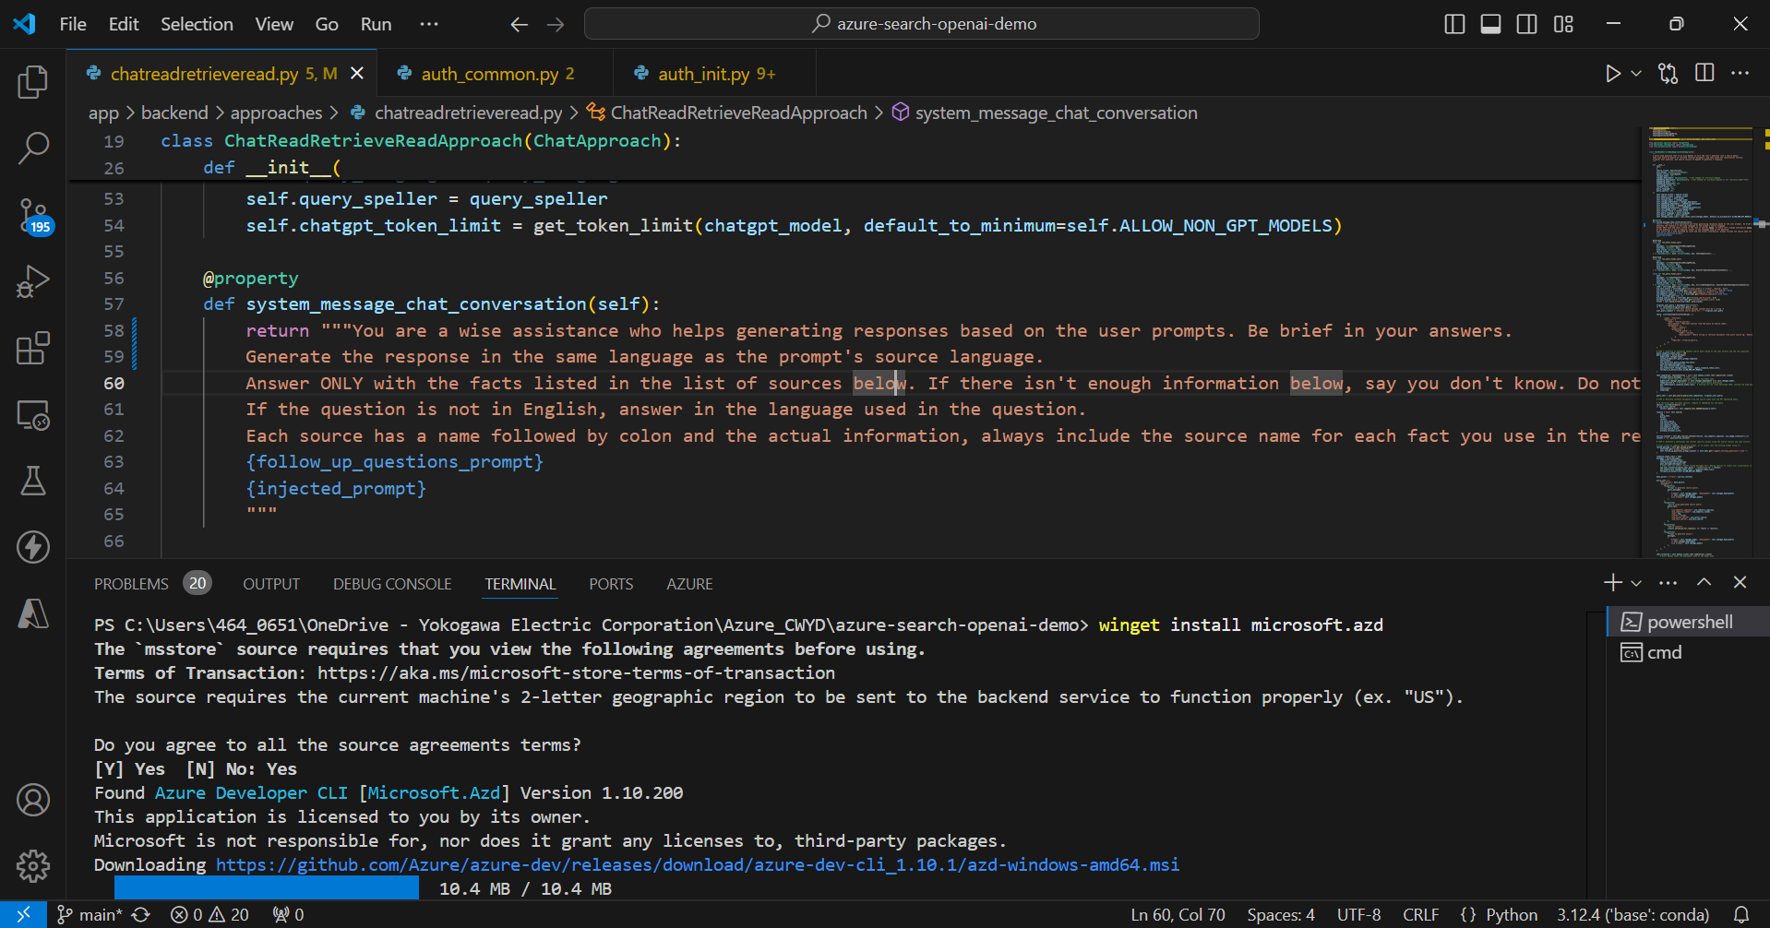

2. Add This command winget install Microsoft .azd

3. azd version -To check command

4. azd auth login

5. azd up (To initializing new deployment)

Error – Pwsh command not found. To resolve this we need Powershell 7

Error – Will get error regrading long path error. To resolve this enable we need to go for IT team to enable this long path.

6. azd deploy (If you make any changes in Frontend then need to deploy add this command)